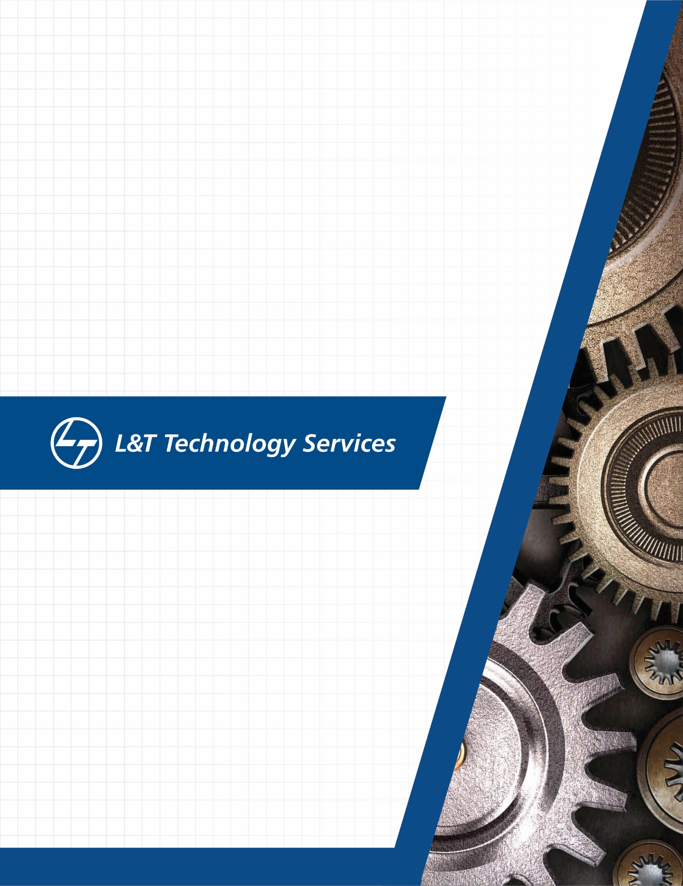
./
GENESIS - Learning Outcome & Mini-project Summary Report

Ver. Rel. No. | Release Date | Prepared. By | Reviewed By | To be Approved | Remarks/Revision Details
Details

Contents
Contents 3
List of Figures 3
List of Tables 4
Miniproject -1 [Individual] 5
Module/s 5
Topic and Subtopics 5
Objectives & Requirements 5
Design 6
Test Plan 9
Implementation Summary 11
Video Summary 11
Git Link 11
Git Dashboard 11
Summary 12
Individual Contribution & Highlights 15
Summary 16
Challenges faced and how were they overcome 16
Future Scope (If applicable) 16
Miniproject -2 [Team/Individual] 17
Module/s 17
Topic and Subtopics 17
Objectives & Requirements 20
Design 20
Test Plan 20
Implementation Summary 20
Git Link 20
Git Dashboard 20
Summary 20
Individual Contribution & Highlights 20
Summary 20
Challenges faced and how were they overcome 20

List of Figures

Figure 1: Component Diagram 7
Figure 2: Deployment Diagram 8
Figure 3: Use case diagram 9
Figure 4: Activity diagram 10
Figure 5: Git Badges 14
Figure 6: Make 15
Figure 7: Build History 16
Figure 8: Codacy 17
Figure 9: Issue 17

List of Tables

Table 1: High level requirements 7
Table 2: Low level requirements 8
Table 3: High level test cases 12
Table 4: Low level test cases 13

Miniproject -1 [Individual]

Module/s
Modules linked to the miniproject are:
- SDLC
- C++

Topic and Subtopics
- SDLC
- Product Definition
Product definition include the detailed definition of the product means how the product will get work, what will be the functionality of the product and how that product will be useful to the user.

- Requirements
Basically, requirements are statements that indicate what a system needs to do in order to provide a capability. These are generally prepared during the early stages of a project's system development lifecycle. The requirements could be high level requirement or low-level requirements. High level requirements mean specifying user goals and constraints on those goals whereas specifying how the user will interact with the product in order to satisfy those goals and constraints is called low-level requirements.

- UML Diagrams
UML Diagrams are nothing but the Unified Modeling Language diagrams. They provides the visual representation of the system. By using visual representations, we can better understand possible flaws or errors in product.

- Test Plan
A TEST PLAN is a document describing software testing scope and activities. It is a document describing the scope, approach, resources and schedule of intended test activities. It identifies amongst others test items, the features to be tested, the testing tasks. It contains high level test cases as well as low level test cases.

- C++
- File handling
File Handling is the storing of data in a file using a program. File handling provides a mechanism to store the output of a program in a file and to perform various operations on it.

- Virtual functions
A virtual function is a member function which is declared within a base class and is re-defined (Overridden) by a derived class. They are mainly used to achieve Runtime polymorphism. Functions are declared with a virtual keyword in base class. The resolving of function call is done at Run-time.

- Inheritance
The capability of a class to derive properties and characteristics from another class is called Inheritance. Inheritance is one of the most important features of Object Oriented Programming. The class that inherits properties from another class is called Sub class or Derived Class and the class whose properties are inherited by sub class is called Base Class or Super class.

- Operator Overloading
Operator overloading is an important concept in C++. It is a type of polymorphism in which an operator is overloaded to give user defined meaning to it. Overloaded operator is used to perform operation on user-defined data type.

Product Definition- Bank Management System
The Movie Database is an application for maintaining a person's account in a bank. In this project I tried to show the working of a banking account system and cover the basic functionality of a Bank Account Management System. To develop a project for solving financial applications of a customer in banking environment to nurture the needs of an end banking user by providing various ways to perform banking tasks. Also, to enable the user’s work space to have additional functionalities which are not provided under a conventional banking project. The Bank Account Management System undertaken as a project is based on relevant technologies. The main aim of this project is to develop software for Bank Account Management System. This project has been developed to carry out the processes easily and quickly, which is not possible with the manuals systems, which are overcome by this software.

Objectives & Requirements
High level requirements:
- User should be able to debit the amount from the account
- User should be able to credit the amount
- User should be able to update the account details
- User should be able to see the account details
Low level requirements:
- Technology
- Database

High level requirements:

ID | Description
HL_01 | The user should be able to query the insights required from the data.
HL_02 | Results are displayed to the user in effective way.
HL_03 | The database should be updatable as and when new records are generated.
Table 1: High level requirements

Low level requirements:
ID | Description
LL_01 | The user is provided with the menu of the various functions the system offer. All functions are implemented effectively.
LL_02 | The function chosen by the user is implemented and various computation and analysis is performed on the database to retrieve the result and displayed to the user.
LL_03 | Add match and remove match functionalities are implemented to keep the database updated.
Table 2: Low level requirements

Design

Structural Diagrams
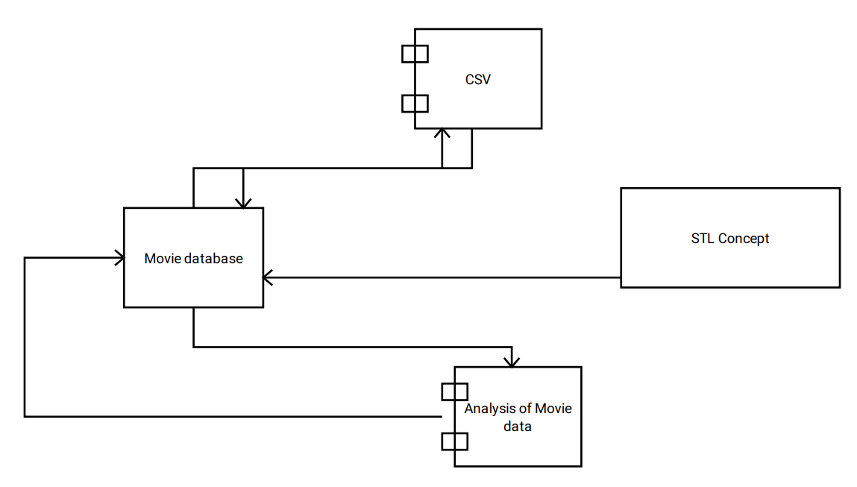
Figure 1: Component Diagram

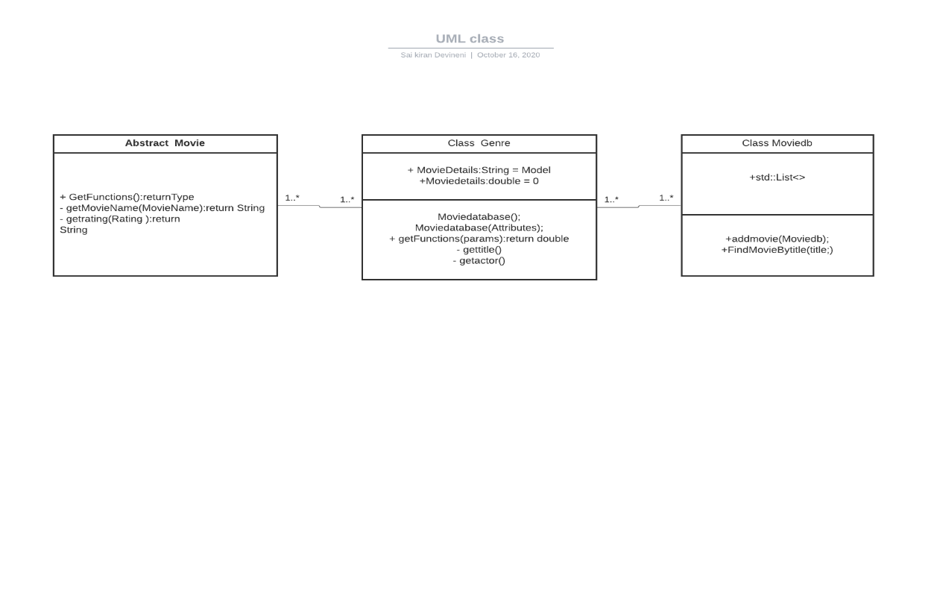
Figure 2: Class Diagram

Behavioral Diagrams

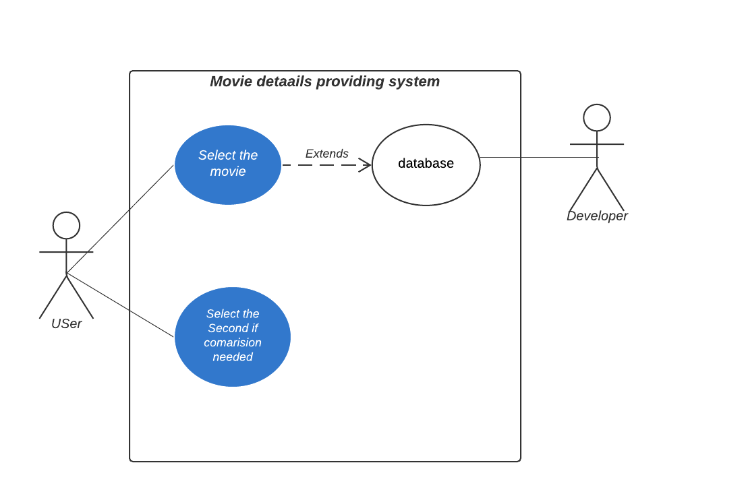Figure 3: Use case diagram

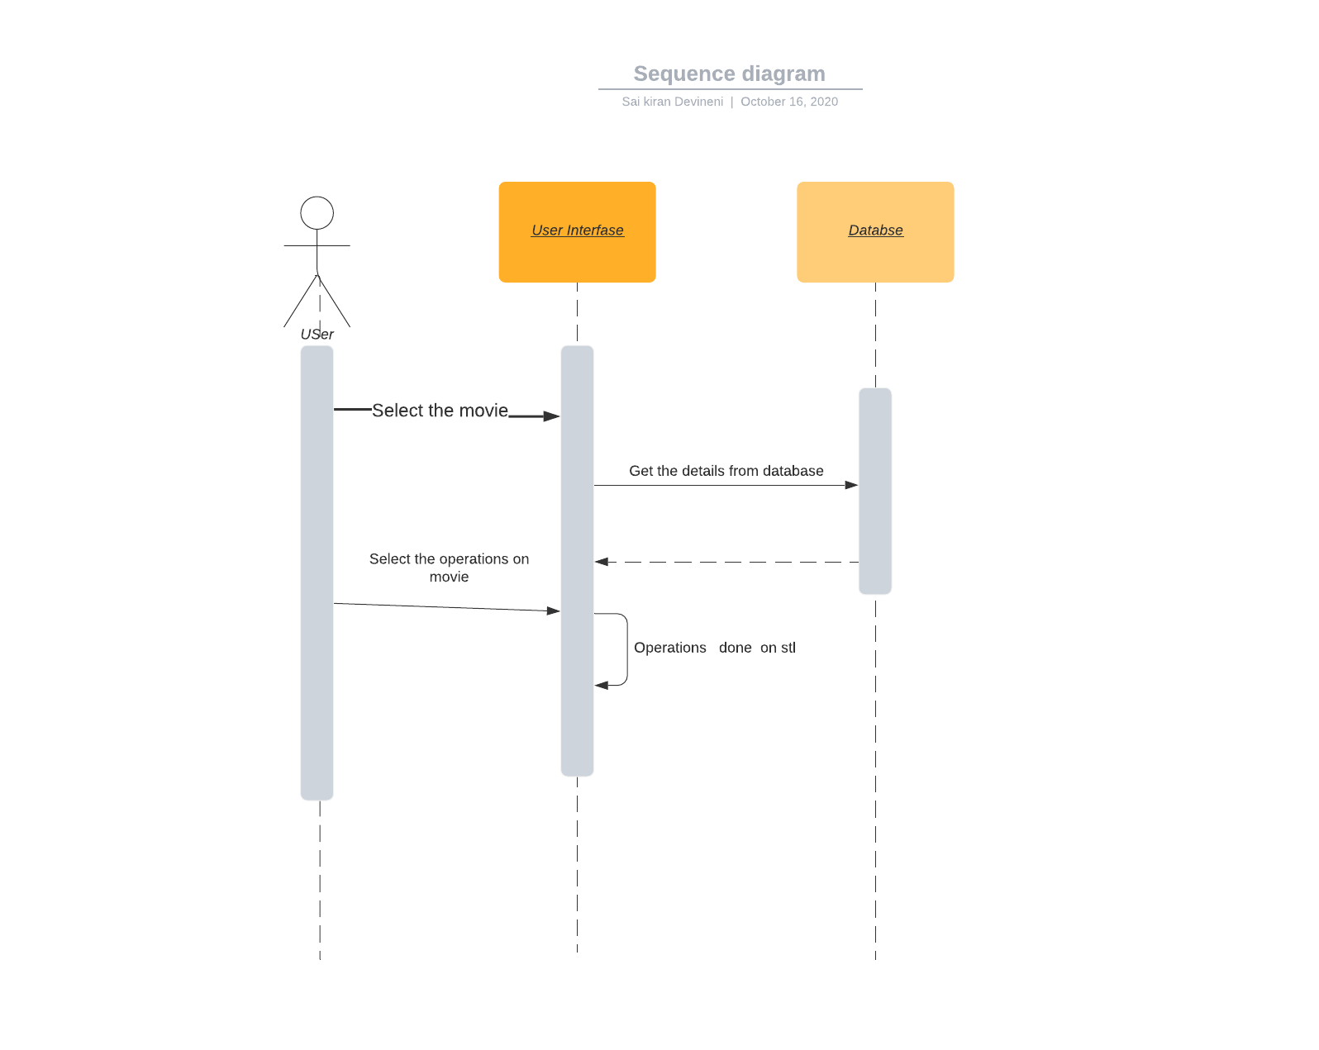

Figure 4: Activity diagram

Test Plan
High level test cases:

Test_id | Description | Expected input | Expected output | Actual output
T_01 | Menu display | System is turned on. | Display the data base of movie | Display the menu of functions
T_02 | Finding movie by id(title) | Choosing appropriate function and provide input as title name | Give the count by analysing data from database class | Counts the total movies in database and displays the value
T_03 | Removing movie from dataset | Choosing appropriate function and provide input actor name | Give the count by analysing data from database class | Counts the total matches in database and displays the value
Table 3: High level test cases

Low level test cases:

Test_id | Description | Expected input | Expected output | Actual output
T_01 | Providing specific moviename/ directorname/ actorname/ acttessname | Choosing appropriate getTitle/ getDirector(), getActor()/ getActress() | Appropriate movie name/ Director name/ Actor name/ Actress name | Director name/ Title name/ Actorname/ Actress name/ details are displayed
T_02 | Using virtualfunctions | Choosing person budget and allowing him to the theatre ,it might be INOX,PVP or a local theatre | Type of theatre . | Theatre type is displayed which is proportional to persons budget.
T_03 | Adding movies with no specified attributes | Just select the add function from menu | Empty record inserted in the database class | Acknowledgement is displayed
T_04 | Adding matches with specified attributes | Providing movie details with all its attribute values like name of the director,actor,actress,title of the movie. | The record will get inserted into the database. | Acknowledgement is displayed
Table 4: Low level test cases

Implementation Summary
“Section focused toward’ s implementation aspects. Here it is only core summary while all the details are in the Git Repo
Note: The GitHub private repo should be documented (Readme.md files at each folder level)
Ensure code quality and clean code and description practices
Mandatory: To add the GitHub user - stepin654321 as a contributor to the repo”

Video Summary
“Please upload a short video on the repo for the walkthrough of the project (Team/Individual) less than 7min and less than 30MB File Size. Start is the Standard opening slide with title of miniproject + Team members followed by the walkthrough”

Git Link
https://github.com/99002660/MiniProject

Git Dashboard
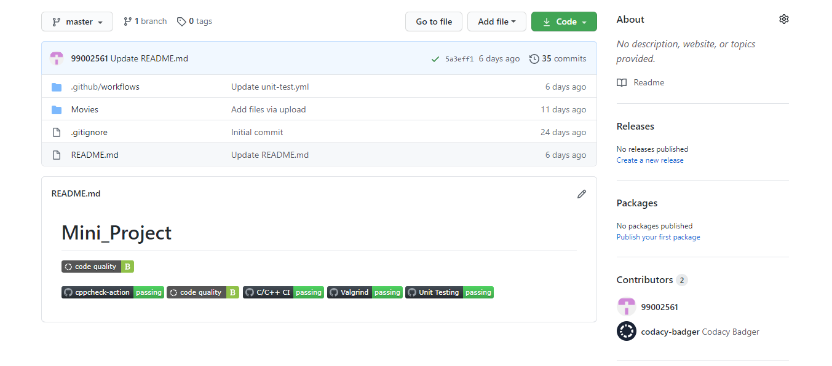
Figure 5: Git Badges
The above image is the screenshot of all the badges available on the Git for the bank management system:
- Code quality
- Cppcheck
- Valgrind
- Unit testing
- Build

Summary
The below link provides the overall step by step implementation of the project.
https://github.com/99002660/MiniProject/blob/master/Bank%20Management%20System.pdf

Git inspector summary
“In linux install gitinspector and Run the command –
gitinspector -H -l -m -T -w -r --grading --format=html > gitinsp.html
and upload the same to your repo and paste the snapshot in the report”

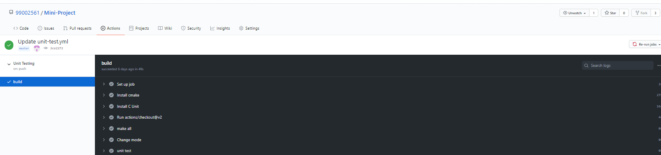
Figure 6: Make

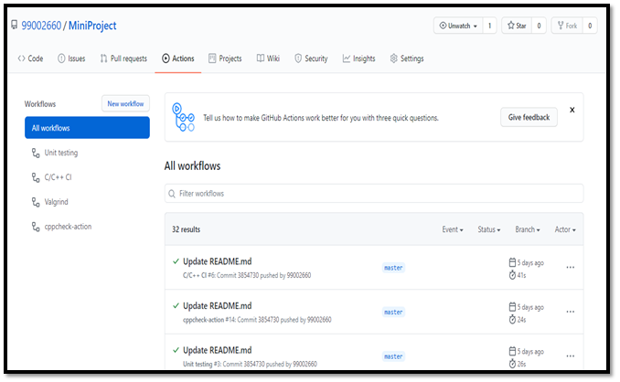
Figure 7: Build History

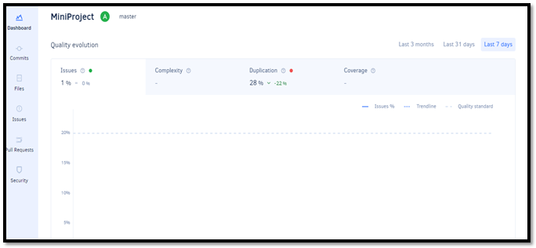
Code quality and Issues or Bug Tracking

Figure 8: Codacy

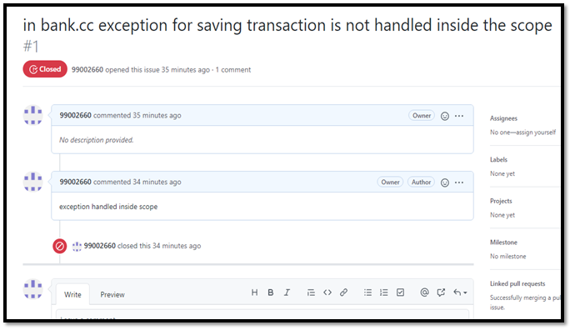
Figure 9: Issue

Individual Contribution & Highlights

Summary
The intended project is implemented for doing general banking operations. And project is documented in such a way that it should follow the different stages of software development life cycle. There are various git operations are implemented for this project like codequality, unit testing, valgrind, cppcheck, build.

Challenges faced and how were they overcome
Challenges occurred while specifying the requirements and test plan like how to define high level and low-level requirements as well as test cases. I referred some online document for different projects and understand what the exact role of high level is and low-level aspect.
I faced some challenges while working with Git. The I learned how to use Git from online tutorials and learned how to perform basic operations and developed make, unit testing, cppcheck and valgrind for my project.

Future Scope (If applicable)
- There is a scope in this project is that we can allow user to perform various banking operation for different bank account.
- Can add various features like loan entry, managing bills, etc.

Miniproject -2 [Team/Individual]

Module/s
- SDLC
- Python

Topic and Subtopics
  - SDLC
- Product Definition
Product definition include the detailed definition of the product means how the product will get work, what will be the functionality of the product and how that product will be useful to the user.

- Requirements
Basically, requirements are statements that indicate what a system needs to do in order to provide a capability. These are generally prepared during the early stages of a project's system development lifecycle. The requirements could be high level requirement or low-level requirements. High level requirements mean specifying user goals and constraints on those goals whereas specifying how the user will interact with the product in order to satisfy those goals and constraints is called low-level requirements.

- UML Diagrams
UML Diagrams are nothing but the Unified Modeling Language diagrams. They provides the visual representation of the system. By using visual representations, we can better understand possible flaws or errors in product.

- Test Plan
A TEST PLAN is a document describing software testing scope and activities. It is a document describing the scope, approach, resources and schedule of intended test activities. It identifies amongst others test items, the features to be tested, the testing tasks. It contains high level test cases as well as low level test cases.

  - Python

- Regular expressions:
A regular expression (or RE) specifies a set of strings that matches it; the functions in this module let you check if a string matches a given regular expression (or if a given regular expression matches a string, which comes down to the same thing).
- Multithreading:
Running several threads is like running several different programs concurrently, but with the following benefits:
- Multiple threads within a process share the same data space with the main thread and can therefore share information or communicate with each other more easily than if they were separate processes.
- Threads are sometimes called light-weight processes and they do not require much memory overhead; they are cheaper than processes.
- Network programming:
Python provides two levels of access to network services. At a low level, you can access the basic socket support in the underlying operating system, which allows you to implement clients and servers for both connection-oriented and connectionless protocols.
Sockets are the endpoints of a bidirectional communications channel. Sockets may communicate within a process, between processes on the same machine, or between processes on different continents.
To create a socket, you must use the socket.socket() function available in socket module, which has the general syntax:
s = socket.socket (socket_family, socket_type, protocol=0)
Here is the description of the parameters –
- socket_family − This is either AF_UNIX or AF_INET
- socket_type − This is either SOCK_STREAM or SOCK_DGRAM.
- protocol − This is usually left out, defaulting to 0.
Server Socket Methods
  - s.bind()
This method binds the address (hostname, port number pair) to socket.
  - s.listen()
This method sets up and starts a TCP listener.
  - s.accept()
This passively accepts TCP client connection, waiting until connection arrives (blocking).
General Socket Methods
  - s.recv()
This method receives TCP messages.
  - s.send()
This method transmits TCP messages.
  - s.sendto()
This method transmits UDP messages.
Client Socket Methods
  - s.connect()
This method actively initiates TCP server connection.

  - Object serialization:
Serialization is the process of translating data structures or object state into a format that can be stored or transmitted and reconstructed later.
dump() − The dump() method serializes to an open file (file-like object).
dumps() − Serializes to a string
load() − Deserializes from an open-like object.
loads() − Deserializes from a string.

Objectives & Requirements

Design

Test Plan

Implementation Summary

Git Link

Git Dashboard

Summary

Git inspector summary

Build

Code quality

Unit Testing

Issues

Individual Contribution & Highlights

Summary

Challenges faced and how were they overcome

